**Ipost list bugs**

1. News list

 - Paging error

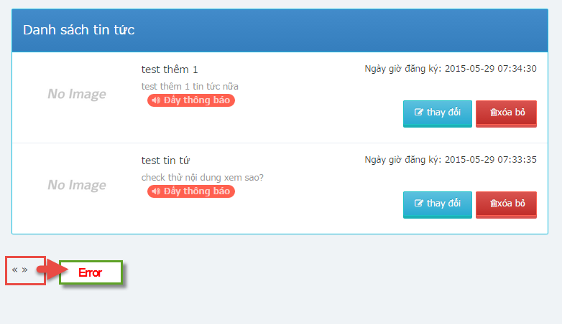

1. Menu

 - Error in create new, edit, delete function

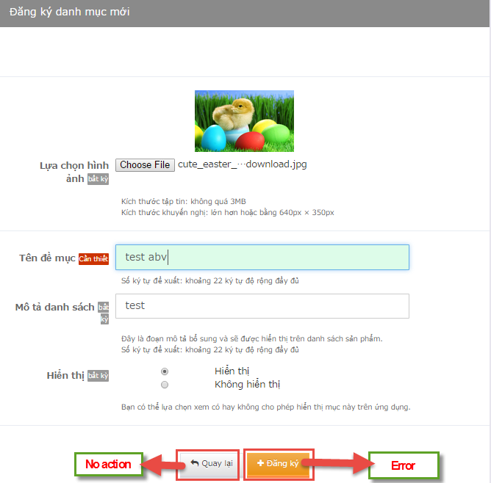

1. Coupon

 - Empty? Do not have any function here?

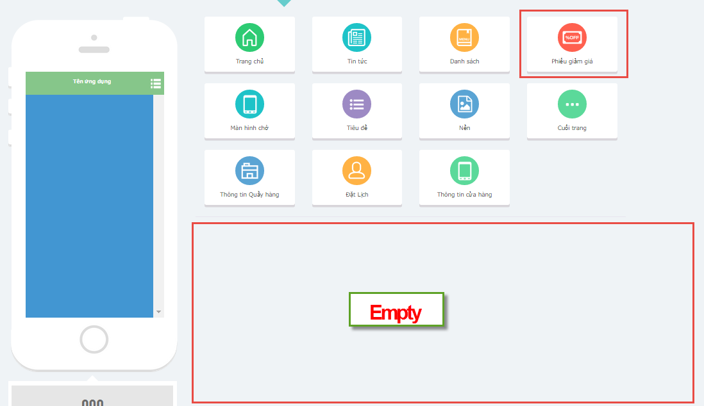

1. Splash

 - Setting image => error, can not display to preview image in Admin panel

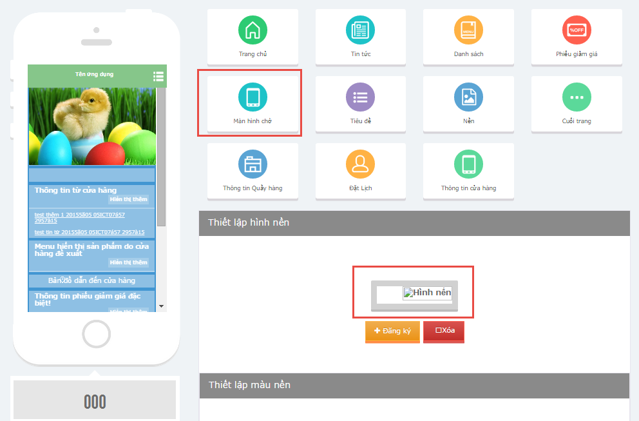

1. Background

 - Setting background image => error, can not display to preview image in Admin panel

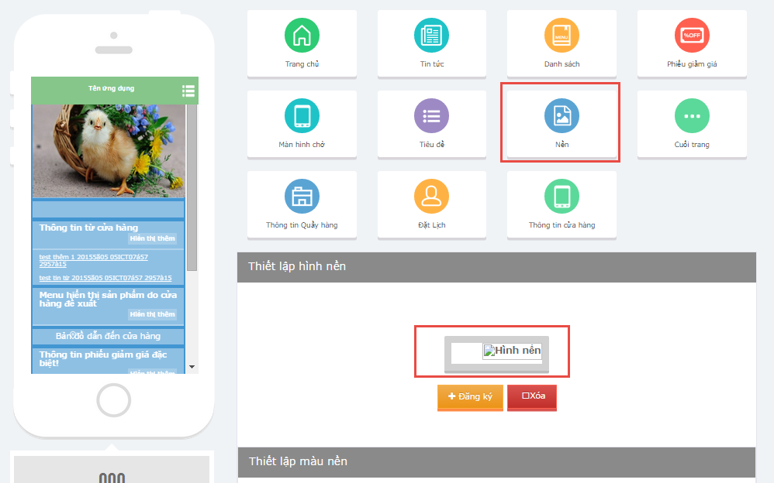

1. Shop profile

* Change Store’s image => error, can not display to preview image in Admin panel

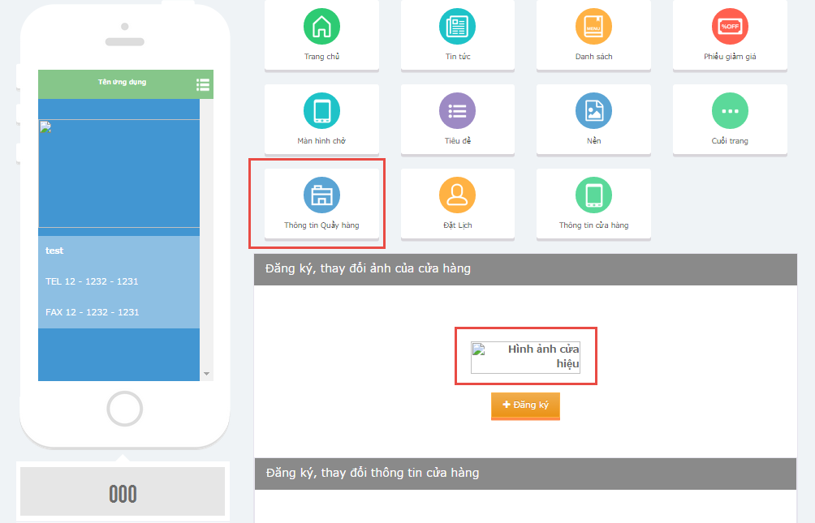

7. Header menu

Can you please guide us to change language for this part? This is fixed in source code?

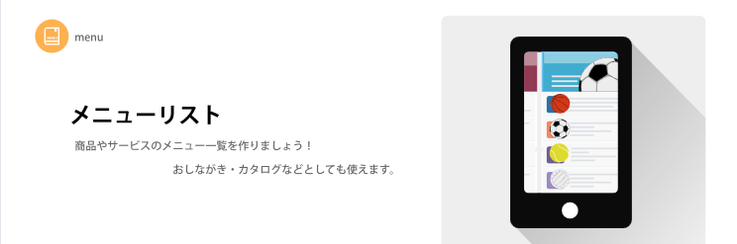

8. Menu

- Upload an image => Not display (No image as shown below)

- Click button [変更], button [削除], button [商品の追加] => No action?

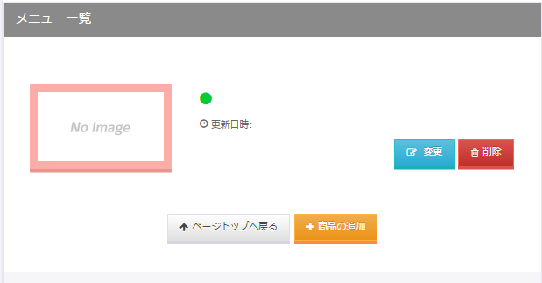

9. スプラッシュ

- Can you please guide us to change language for this part? This is fixed in source code?

